**SHORT ANSWER**

1. You are a venture capitalist. Calculate the Profit Margin for 2014 for the startup whose income statement is shown below (show work).

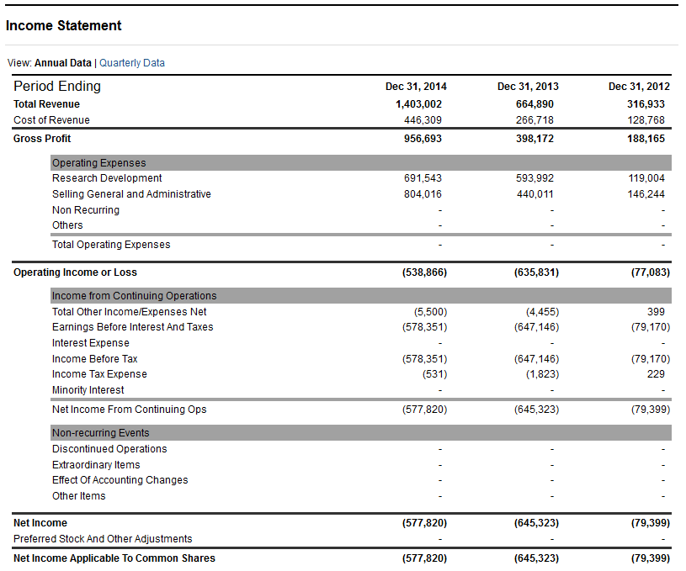

1. As the VC looking to invest in this business discuss what this number means, some reasons why this number might be low and why you still might invest (or not invest).
2. An entrepreneur decides to invest 1.2 million for a 20% stake in your business. What valuation does this put on your business? (Show work)
3. How many cups of coffee must you sell to break even if each cup of coffee sells for $4.5 with variable costs of $2.5 per cup. Your fixed costs are 1374 per month.
4. Why might you seek VC funding over an angel investment
5. At which stage of the business might one be more appropriate than the other
6. Your business has made 20 million gross revenue with a net profit margin of 10%. An investor put in an initial investment of $500,000 for a 20% equity stake in the company. Have they made their investment back and was this a good investment.

**LONG ANSWER**

1. You want to enter the market by starting a Coffee Shop, but want to do some analysis of what the industry is like before making a decision. You decide to use Porter’s Five Forces to analyze Starbucks since you see them as an important industry leader.
   1. In the space below use the 5 Forces to conduct this analysis of Starbucks.
   2. Does your outcome make this appear like an attractive market to enter?
   3. Starbucks has done quite well, does your outcome agree with how well Starbucks has done?

Amanda has decided to open a sandwich shop and her friends say the best sandwich she makes is her Swiss Gobbler Turkey sandwich. She has shopped the competition in her area and decided she should charge $4.95 per sandwich. Let’s see how many Swiss Gobbler sandwiches she needs to sell to break even and how many she needs to sell to make $500 net profit each month.

**List of Amanda’s expenses - Sort them into either the Variable Expenses or Fixed Expenses column:**

Turkey per sandwich- $0.60 Mustard - $0.03

Rent per month - $600 Bookkeeper per month- $50

Swiss cheese per sandwich - $0.60 Lettuce - $0.04

Bread per sandwich - $0.05 Owner’s salary per month - $2,000

Telephone per month - $100 Secret sauce - $0.15

Labor to prepare sandwich - $0.53 Paper to wrap sandwich - $0.03

Utilities per month - $150 Tomato - $0.06

Insurance per month - $25

Variable Expenses: Fixed Expenses:

_________________ $_____________ ___________________________ $_____________

___________________________ $_____________ ___________________________ $_____________

___________________________ $_____________ ___________________________ $_____________

___________________________ $_____________ ___________________________ $_____________

___________________________ $_____________ ___________________________ $_____________

___________________________ $_____________ ___________________________ $_____________

___________________________ $_____________ ___________________________ $_____________

___________________________ $_____________ ___________________________ $_____________

___________________________ $_____________ ___________________________ $_____________

___________________________ $_____________ ___________________________ $_____________

*Total Variable Expenses* $_____________ *Total Fixed Expenses* $_____________

(*per sandwich) (per month)*

The **Gross Profit** is the selling price per sandwich minus the variable expenses per sandwich.

What is the selling price of the Swiss Gobbler Turkey Sandwich? (+) $____________

What are the variable expenses of each sandwich? (-) $____________

What is the gross profit for each sandwich? (=) $____________

The Gross Profit represents how much each sandwich “contributes” toward fixed expenses and profits. Every time Amanda sells a sandwich, how much is it contributing toward paying her fixed expenses? $____________

What are Amanda’s total fixed expenses per month? $____________ per month

What is the gross profit that contributes to that monthly expense? $____________per sandwich

How many Swiss Gobbler Sandwiches does Amanda need to sell every month to pay her monthly expenses?

____________ sandwiches

(Fixed Expenses divided by Gross Profit = number of sandwiches she needs to sell

to break even.)

How many additional sandwiches does Amanda need to sell every month to make $500 Net Profit? ____________

(Net Profit divided by Gross Profit = number of additional sandwiches

she needs to sell to make her Net Profit goal.)